**WORKSHEET 9**

**Student Name:** Vivek Kumar **UID:** 21BCS8129

**DOMAIN CAMP:** 16-01-2023 to 28-01-2023 **Section/Group:** DWWC-77

**Subject Name:** IT Skills (DSA)

# Question 1. MAXIMUM SUBARRAY

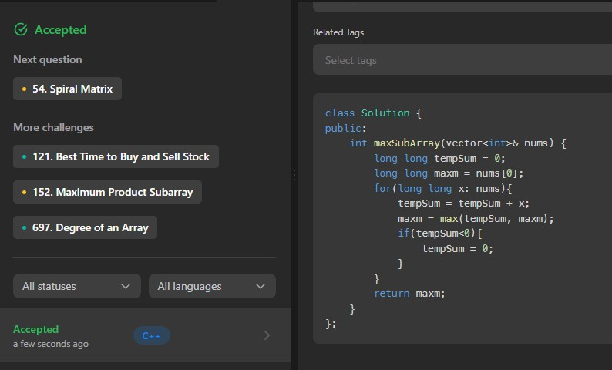

# Question 2. CLIMBING STAIRS

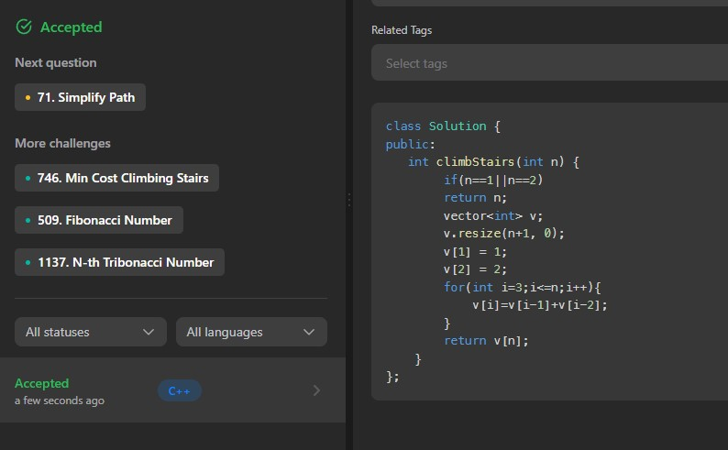

# 3. PASCAL’S TRIANGLE

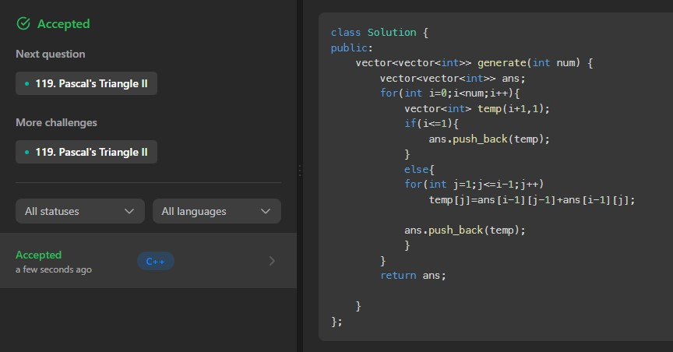

# Question 4. LONGEST PALINDROMIC SUBSTRING

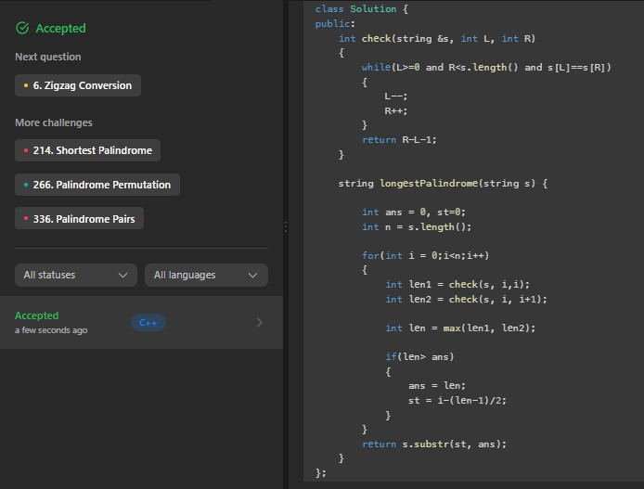

# 5. FIBONACCI NUMBER

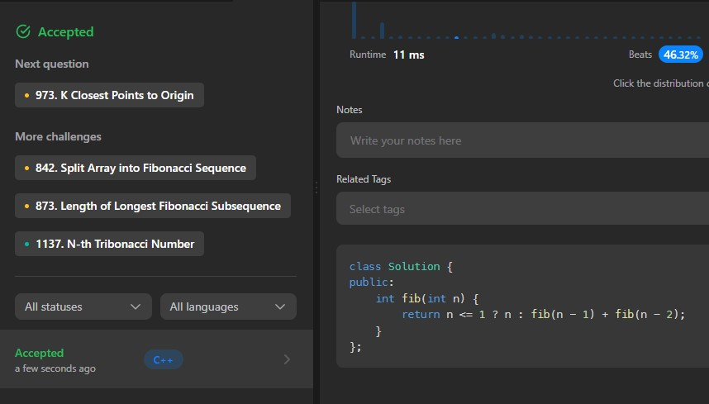

# Question 6. MAXIMUM PROFIT IN JOB SCHEDULING

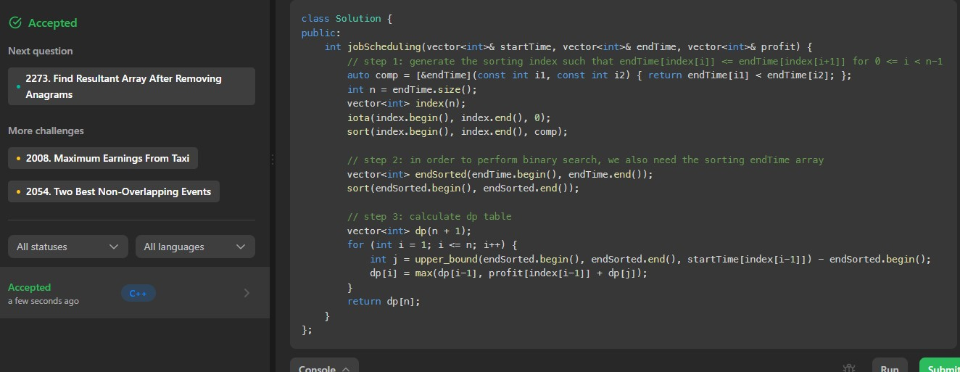

# 7. UNIQUE PATHS

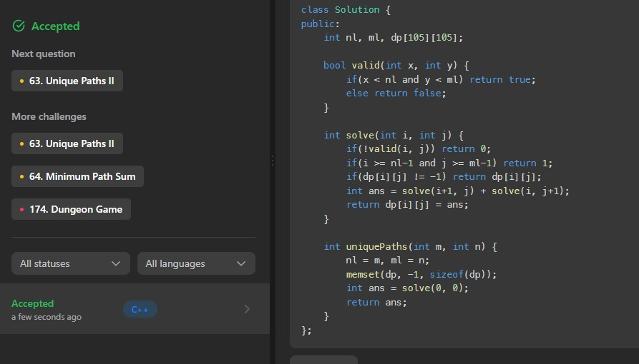

# Question 8. PERFECT SQUARES

